Writing has a rhythm:

*BLUF sample: Team Munchly believes with moderate confidence that ……. because ….. The likelihood that …..*

*Team Savage Beauty (TSB) asserts with moderate confidence that Faya Largeau (FY) is a Russian front company. The equipment bought from FY is likely vulnerable to supply chain threats. Supply chain threats may introduce vulnerabilities affecting our widget development and distribution network.*

**There is a rhythm to the BLUF**

**Team NAME believes with Moderate confidence that WHO/WHAT is DOING WHAT for the purposes of espionage .**

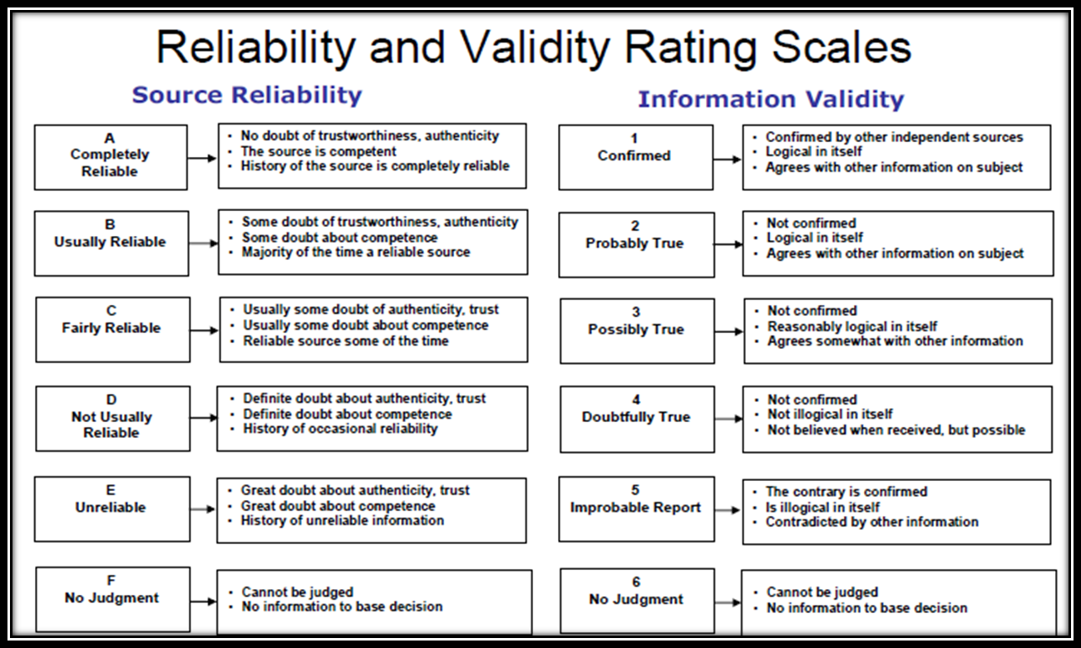

Figure 1 NATO Admiralty Scoring

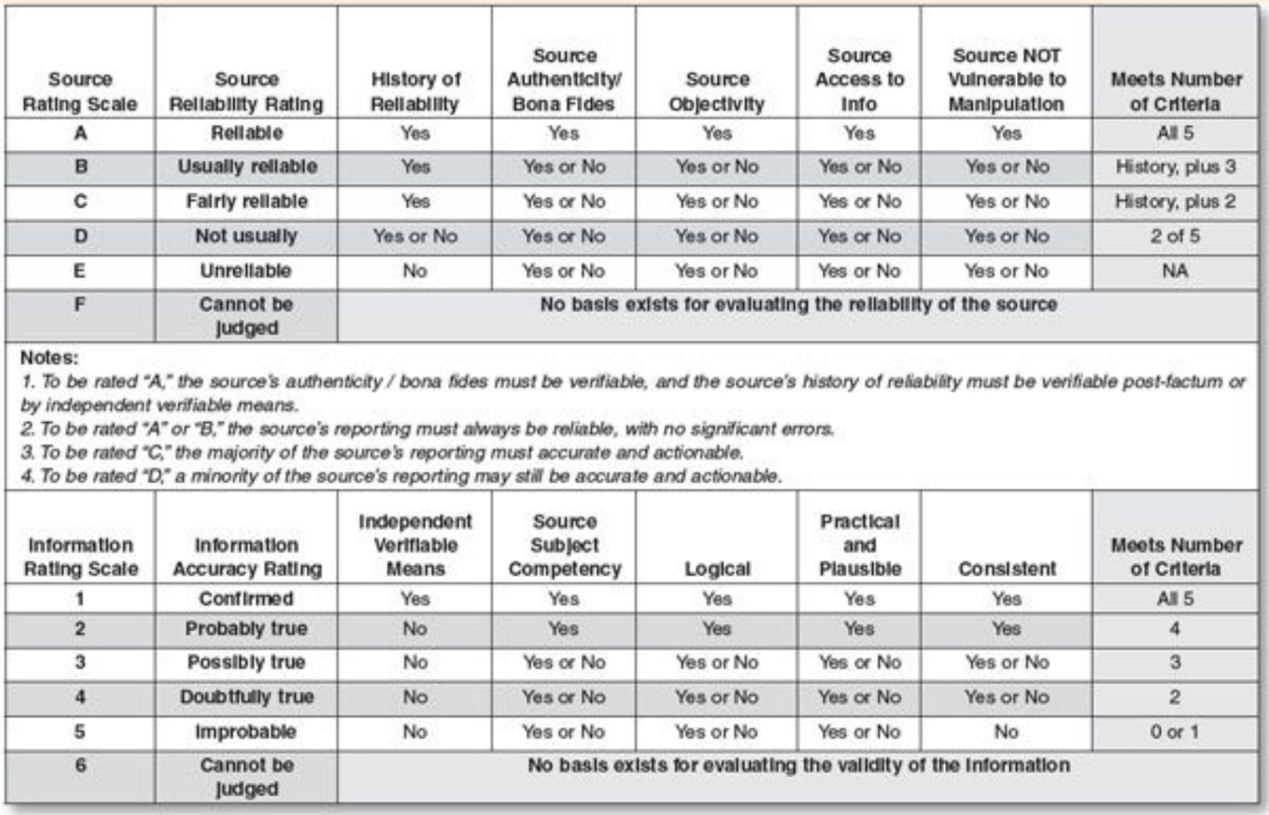

Figure 2 Supporting Scoring

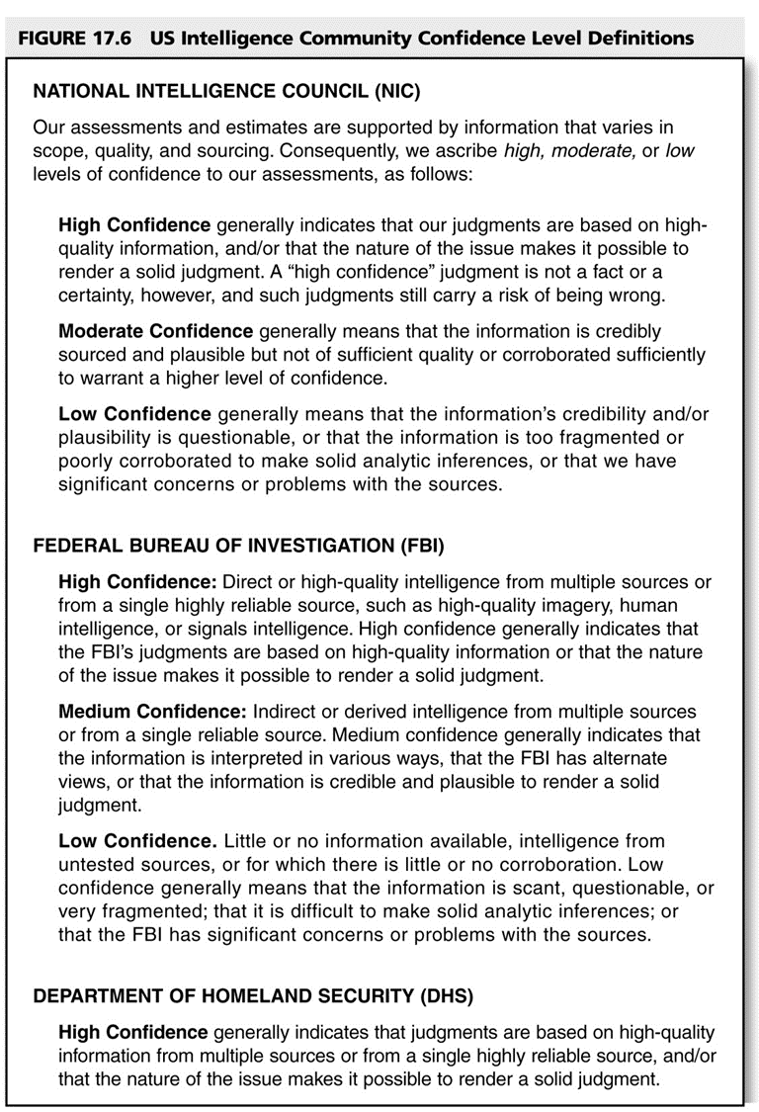

Figure 3 Confidence Levels

**Probability and Likelihood Wording**

We use phrases such as we judge, we assess, and we estimate—and probabilistic terms such as probably and likely—to convey analytical assessments and judgments.

Such statements are not facts, proof, or knowledge.

These assessments and judgments generally are based on collected information, which often is incomplete or fragmentary.

Some assessments are built on previous judgments.

In all cases, assessments and judgments are not intended to imply that we have “proof” that shows something to be a fact or that definitively links two items or issues.

Words of Estimative Probability – Sherman Kent (In your Kindle under documents)

|  |  |
| --- | --- |
|  | Chances Out of 100 |
| Are | 90 - 100 |
| Will | 90 - 100 |
| Almost Certainly | 80 - 100 |
| Undoubtedly | 80 - 100 |
| Highly Likely | 75 - 95 |
| Highly Probable | 75 - 95 |
| Probably Will | 70 - 90 |
| Probably | 60 - 80 |
| Likely | 60 - 80 |
| Good Chance | 60 - 80 |
| Seems Likely | 60 - 80 |
| Better Than Even Chance | 50 - 70 |
| May | 40 - 60 |
| Probably Not | 10 - 30 |
| Unlikely | 10 - 30 |
| Some Slight Chance | 0 - 20 |

|  |  |  |  |  |  |
| --- | --- | --- | --- | --- | --- |
|  | Analyst | Policy |  | Analyst | Policy |
| Undoubtedly | 100 | -- | Undoubtedly | 100 | 90 |
| Believe | 80 | 80 | Believe | 70 | 70 |
| Estimate | 80 | 80 | Estimate | 75 | 70 |
| Apparently | 70 | -- | Apparently | 70 | -- |
| Indicates that | 70 | -- | Indicates that | 70 | -- |
| Believe the Chances are Good | 70 | -- | Good Chance | 70 | 70 |
| Possible | 50 | 50 | Possibly | 50 | 50 |
| Might | 50 | -- | Might | 50 | 50 |

|  |  |  |
| --- | --- | --- |
| Most Frequent Response | Analyst | Policy |
| Undoubtedly | 100 | 90 |
| Highly Probable | 90 | 85 |
| Highly Likely | 90 | 80 |
| Probably | 75 | 70 |
| Estimate | 75 | 70 |

|  |  |  |  |  |
| --- | --- | --- | --- | --- |
| Expression | Odds - Most Frequent Response | | Percent Agreeing within 10 Points | |
|  | Analyst | Policy | Analyst | Policy |
| Category A (90 % - 100 % Consensus) | | | | |
| Almost Certainly | 90 | 90 | 99 % | 94 % |
| Are | 100 | 100 | 96 % | 92 % |
| Will | 100 | 100 | 91 % | 91% |
| Category B (70 % - 89 % Consensus) | | | | |
| Probably | 75 | 70 | 90 % | 86 % |
| Probably not | 20 | 20 | 85 % | 76 % |
| Probably will | 80 | -- | 85 % | -- |
| Highly probably | 90 | 85 | 83 % | 87 % |
| Likely | 70 | -- | 83 % | -- |
| Undoubtedly | 100 | 90 | 81 % | 86 % |
| Good chance | 70 | 70 | 81 % | 81 % |
| Highly likely | 90 | 80 | 80 % | 81 % |
| Unlikely | 20 | 20 | 80 % | 79 % |
| Seems likely | 70 | -- | 80 % | -- |
| Better than even chance | 60 | 60 | 78 % | 87 % |
| Some slight chance | 10 | 10 | 77 % | 79 % |
| May | 50 | -- | 73 % | -- |

|  |  |  |  |  |
| --- | --- | --- | --- | --- |
| Expression | Odds -- Most Frequent Response | | Percent Agreeing within 10 Points | |
|  | Analyst | Policy | Analyst | Policy |
| Category C (No Consensus) | | | | |
| Seems unlikely | 20 | -- | 68 % | -- |
| Might | 50 | 50 | 66 % | 59 % |
| May indicate | 50 | -- | 66 % | -- |
| Could be expected | 60 | -- | 65 % | -- |
| Expect | 80 | -- | 64 % | -- |
| Could | 50 | 50 | 60 % | 56 % |
| Must | 80 | -- | 59 % | -- |
| Evidently | 70 | -- | 58 % | -- |
| Apparently | 70 | -- | 58 % | -- |
| Suggests | 60 | -- | 58 % | -- |
| Believe | 70 | 70 | 55 % | 54 % |
| Should | 70 | -- | 54 % | -- |
| Possibly | 50 | 50 | 53 % | 51 % |
| Might be expected | 50* | -- | 51 % | -- |
| Indicates that | 70 | -- | 51 % | -- |
| Might be anticipated | 50 | 50 | 56 % | 50 % |
| Apparently is intent | 60* | -- | 50 % | -- |
| Serious possibility | 60* | 70 | 49 % | 55 % |

|  |
| --- |
| We *believe* the *chances are good* that ... |
| We *believe* ... will not be ... |
| *Undoubtedly*, ... will not be ... |
| We *estimate* ... will not be ... |
| Barring ... the economy *will probably* continue ... |

|  |
| --- |
| *Apparently*, ... will not be ... |
| If ... continue ... , the president *might* ... be willing ... |
| ... *might* also take ... action ... |
| ... references ... to undiminished importance ... *suggest* a belief ... |
| It is *possible* that ... will become ... |
| ... visit ... *indicates* that ... is being ... |
| ... visit *suggests* ... progress ...[1](https://www.cia.gov/library/center-for-the-study-of-intelligence/kent-csi/vol8no4/html/v08i4a07p_0001.htm#1-the-full-context) |
| We*believe* ... there is a *possibilit*y that ... |
| ... speech ... *conveyed the impression* that ... [2](https://www.cia.gov/library/center-for-the-study-of-intelligence/kent-csi/vol8no4/html/v08i4a07p_0001.htm#2-respondents-were-asked) |
| ... comments *suggest* ... changes may well be less than speech ... *might indicate* ... [3](https://www.cia.gov/library/center-for-the-study-of-intelligence/kent-csi/vol8no4/html/v08i4a07p_0001.htm#3-respondents-were-asked) |